Audio

PAWSv2 has 2 audio channels, via the 3.5 mm jack, channel 1 going to the LEFT speaker, channel 2 going to the RIGHT speaker. Each channel has the same capabilities.

Each channel can operate in one of three modes:

- Waveform Mode
  - Square
  - Sawtooth
  - Triangle
  - Sine
  - User defined
    - 256 entry user defined waveform
- Sample Mode
  - 1-bit sample mode
    - 128 entry 1-bit samples (CHIP8 style) per channel
  - PCM sample mode
    - 20480 3-bit samples per channel (converted from 8-bit during upload)
- Tune mode (Based upon DOOM PC Speaker Samples)
  - 256 entry notes to play in sequence per channels

The following PAWSlibrary functions are used to control the audio system..

Function | Description
void beep( unsigned char channel_number, unsigned char waveform, unsigned char note, unsigned short duration )
void set_volume( unsigned char left, unsigned char right )
void await_beep( unsigned char channel_number )
unsigned short get_beep_active( unsigned char channel_number )
void tune_upload( unsigned char channel_number, unsigned short length, unsigned char *samples )
void bitsample_upload_128( unsigned char channel_number, unsigned char *samples )
void wavesample_upload( unsigned char channel_number, unsigned char *samples )
void pcmsample_upload( unsigned char channel_number, unsigned short count, unsigned char *samples )

The following defines are made in PAWSdefinitions.h to assist with operating the audio system.

Function | Description
AUDIO_SILENCE  LEFT_SILENCE  RIGHT_SILENCE | Pass to beep to silence audio completely, or left/right channel.
CHANNEL_LEFT  CHANNEL_RIGHT  CHANNEL_BOTH | Pass to beep and sample upload functions to specify which channels to operate on.
WAVE_SQUARE  WAVE_SAW  WAVE_TRIANGLE  WAVE_SINE  WAVE_NOISE  WAVE_USER  WAVE_PCM  WAVE_BITS  WAVE_TUNE | Pass to beep to specify which waveform/sample mode to use, or to start the tune playing system.
SAMPLE_REPEAT | Pass to beep OR’d with WAVE_TUNE to keep playing the tune.

Sample NuCu Program

A simple NUCU program that sets the background generator to the BKG_SNOW pattern on a BLACK background, and changes the colour of the snow/stars every 64 pixels down the screen to give a rainbow effect.
copper_startstop( 0 ); // STOP THE COPPER FROM RUNNING

unsigned short memoryinit[8] = {
WHITE,
RED,
ORANGE,
YELLOW,
GREEN,
LTBLUE,
PURPLE,
MAGENTA
};

copper_set_memory( memoryinit ); // PROGRAM COPPER MEMORY ARRAY OF COLOURS

copper_program( 0, CU_SET, CU_BM, CU_RL, BKG_SNOW ); // BACKGROUND SNOW GENERATOR
copper_program( 1, CU_SET, CU_BA, CU_RL, BLACK ); // BACKGROUND ALT BLACK
copper_program( 2, CU_SET, CU_BC, CU_RL, WHITE ); // BACKGROUND WHITE

copper_program( 3, CU_SET, CU_R0, CU_RL, 0 ); // SET R0 = 0

copper_program( 4, CU_SET, CU_R1, CU_RR, CU_R0 ); // SET R1 = R0
copper_program( 5, CU_SHL, CU_R1, CU_RL, 6 ); // R1 = R1 * 64
copper_program( 6, CU_LFM, CU_R2, CU_RR, CU_R0 ); // R2 = MEM[ (R0) ]

copper_program( 7, CU_SEQ, CU_RY, CU_RR, CU_R1 ); // Y == R1 ?
copper_program( 8, CU_JPL, FALSE, CU_RL, 7 ); // SKIP YES, ELSE GO TO 7

copper_program( 9, CU_SET, CU_BC, CU_RR, CU_R2 ); // SET BACKGROUND = R2
copper_program( 10, CU_ADD, CU_R0, CU_RL, 1 ); // R0 = R0 + 1
copper_program( 11, CU_AND, CU_R0, CU_RL, 7 ); // R0 = R0 & 7
copper_program( 12, CU_JPL, 4 ); // JUMP 4

copper_startstop( 1 ); // START THE COPPER
See ASTROIDS / INVADERS / DEMO for this NuCu program running.

NuCu runs at 25MHz which matches the video clock. Each instruction takes 1 cycle, equivalent to 1 pixel.

It should be noted that RX and RY refer to the pixel to be displayed NEXT or during this cycle, RX never goes out of the range 0-639, and RY never goes out of the range 0-479.

If VBLANK or HBLANK, RX will be 0, the next pixel to be displayed on the line.

If VBLANK, RY will be 0, the next line to be displayed, and if HBLANK, RY will the value of the next line to be drawn.

Example screenshots of NuCu Programs:

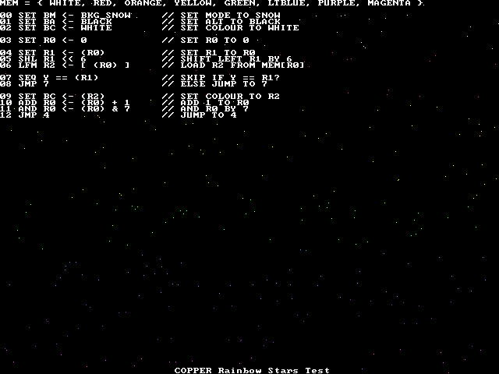 | 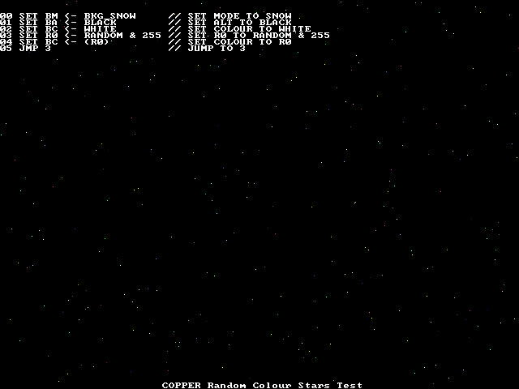
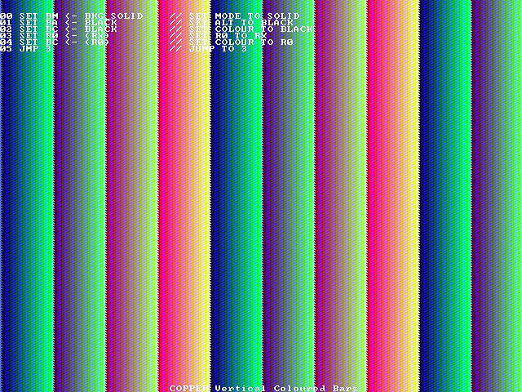 | 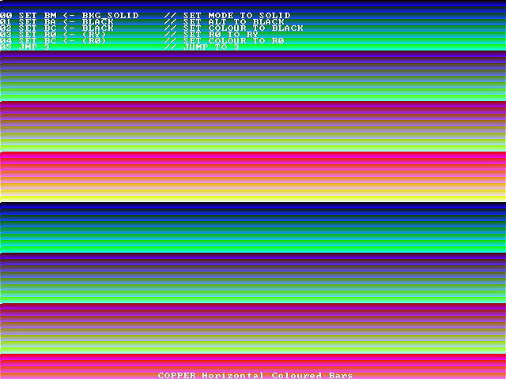

The following PAWSlibrary functions are used to control the background generator and NuCU..

Function | Description
void set_background( unsigned char colour, unsigned char altcolour, unsigned char backgroundmode ) | STOP NuCu and set the background generator parameters directly.
void copper_startstop( unsigned char status ) | TRUE will start NuCu, FALSE will stop NuCu.
void copper_set_memory( unsigned short *memory ) | Upload an array of 8 10-bit numbers to the NuCu memory. These can only be uploaded whilst NuCu is not running.
void copper_program( unsigned char address, unsigned char command, unsigned char reg1, unsigned char flag, unsigned short reg2 ) | Set the program entry at address (0-127) to the opcode command; using reg1 as the destination and source for the first register; flag as the reg2/literal flag; reg2 as the register identifier or literal value.
void set_copper_cpuinput( unsigned short value ) | Set the NuCu CPU input value.
unsigned short get_copper_cpuoutput( void ) | Read the NuCu CPU output value.

